1 : INTRODUCTION :

* WHAT & Why OOP, Benefits , Disadvantage
  1. <https://www.geeksforgeeks.org/benefits-advantages-of-oop/>
  2. 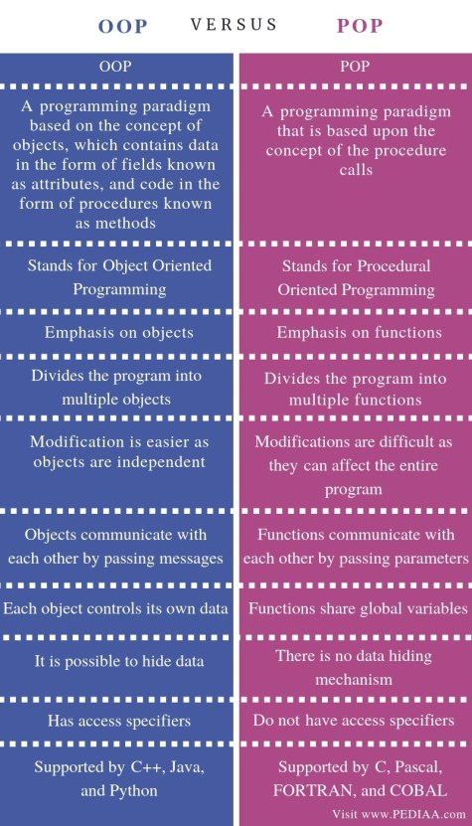
  3. <https://www.youtube.com/watch?v=fx0xXPnvJuM>

**2 . Basic Concepts ( object , class ) :**

1. SIR NOTE CLASSROOM ( <https://classroom.google.com/u/2/c/NTIzMTc4MzQ0OTQ5/m/NjE2OTM0OTg2OTIz/details> )
2. <https://www.javatpoint.com/difference-between-object-and-class#:~:text=Class%20is%20a%20blueprint%20or%20template%20from%20which%20objects%20are%20created.&text=Object%20is%20a%20real%20world,a%20group%20of%20similar%20objects>.

**3. Abstract data type :**

Sir notes in classroom

<https://classroom.google.com/u/2/c/NTIzMTc4MzQ0OTQ5/m/NjE2MjcxNDYyNTM0/details>

2: KEY FEATURES IN JAVA :

1 . Encapsulation :

<https://www.youtube.com/watch?v=3JmMK-HvYJU>

2. Inheritance :

<https://www.geeksforgeeks.org/inheritance-in-java/?ref=lbp>